**NAME: Sharvayu Zade**

**PRN: 23070521135**

**B2 Batch**

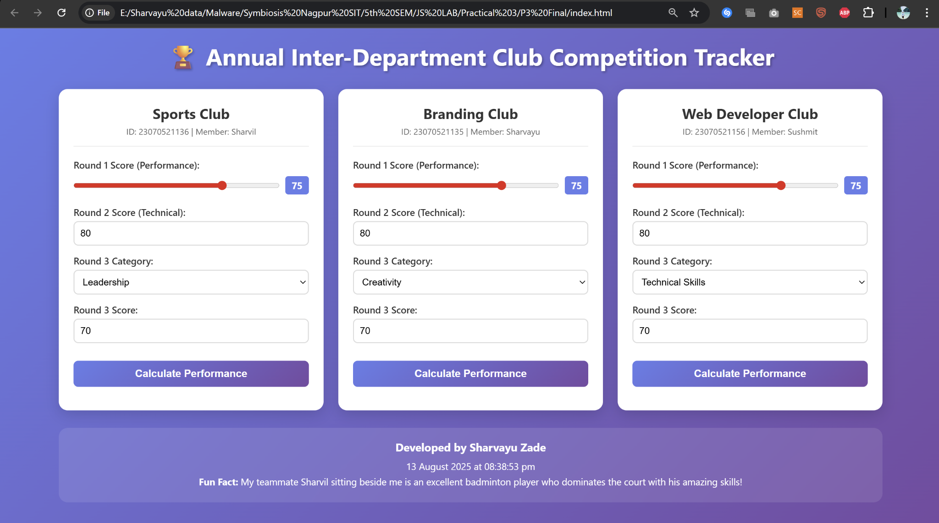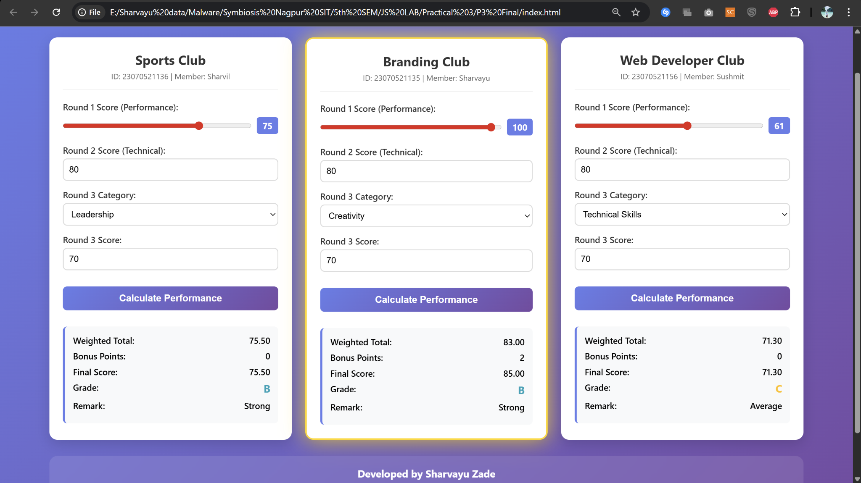

**Task: “Campus Club Performance Tracker” Scenario**

You are the front-end developer for your batch’s **Annual Inter-Department Club Competition**. You must create a **dynamic performance tracker** that records and displays scores for **three real club teams** from your class.

The tracker must adapt to **live inputs**.

**Rules**

1. **Team Names & IDs** must be real - selected from actual classmates. 2. **Criteria Weightings -** these values **must be typed manually** into the JavaScript array. 3. **There must be the Bonus Points**

4. **Tie-breaker condition** must be based on **the first letter of the team name**. 5. Footer must show:

o **Your full name**

o **The date/time**

o **One fun fact about your real teammate sitting beside you**

**Requirements**

**Inputs (for 3 different teams from your batch):**

∙ **Team Name** (text — real club name from your class)

∙ **Team ID** (number — PRN of any one member)

∙ **Round 1 Score** (range slider, 0–100)

∙ **Round 2 Score** (manual number input, 0–100)

∙ **Round 3 Category** (dropdown **generated from a JS array**)

**Processing Logic:**

1. **Calculate Weighted Total**: Multiply each round score by its weight (Assume suitable weights).

2. **Add Bonus Points**: e.g., “+5 if Round 2 > 80” or “+3 if category is ‘Innovation’ 3. **Assign Grade** via if / else if:

o ≥90: **A**

o 75–89: **B**

o 60–74: **C**

o <60: **F**

4. **Assign Remark** via switch:

o A → “Outstanding”

o B → “Strong”

o C → “Average”

o F → “Needs Improvement”

5. **Highlight the highest scorer’s card** (CSS shadow/glow).

6. **If tie**, apply **tie-breaker rule** (Assume suitable rule).

**Validation:**

∙ No score can be below 0 or above 100.

∙ Names must match **actual classmates’ club/team names**.

∙ Dropdown must **randomize order** every page load.

**Output (on the same page — no alerts):**

∙ Team Name & ID

∙ Weighted Total

∙ Grade

∙ Remark

∙ Highlighted Top Card (or tie-breaker winner)

∙ Footer with your name, time, and fun fact about your teammate

**Extra Challenge (Mandatory)**

∙ Add **one custom CSS animation** (e.g., card flip, glow) **triggered after form submission**.

∙ Take a **screenshot** of the filled, working tracker with real team names & submit along with the code.